

Project Report

Commitments of Traders:

Predicting Asset Manager Net S&P500 Futures Position

December 18, 2020

Jack Bai (zitingb) Bryan Ding (bding)

Matthew Lyberg (mlyberg) Chris Wang (xwang4)

Zhenshou Xie (zhenshox) Yiming Xu (yimingxu)

Max Zhang (jingzhez)

Professor Chad Schafer

Professor Max G’Sell

Advisors

**Executive Summary**

We apply Machine Learning techniques to predict Net of Long and Short positions in S&P500 Futures held by Asset Managers as reported in the CFTC’s “Commitment of Traders” report.

Mid-way through the project, we’ve identified candidate predictors, applied basic transformations where appropriate, and analyzed the distributions of the predictors, their correlations with the response, and run a baseline for analysis using regression with regularization (Ridge, LASSO) and Random Forest.

Be careful introducing non-stationary variables. . .there already is a lot of serial correlation.

**Baseline Analysis: Weekly Predictors**

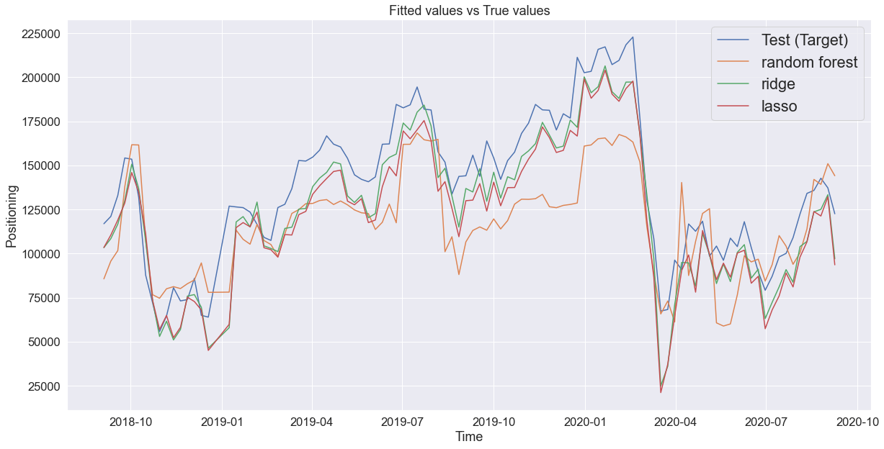

We’ve also identified an interesting relationship between the previous week’s S&P Index change and the change in levels for the Asset Manager Net position:

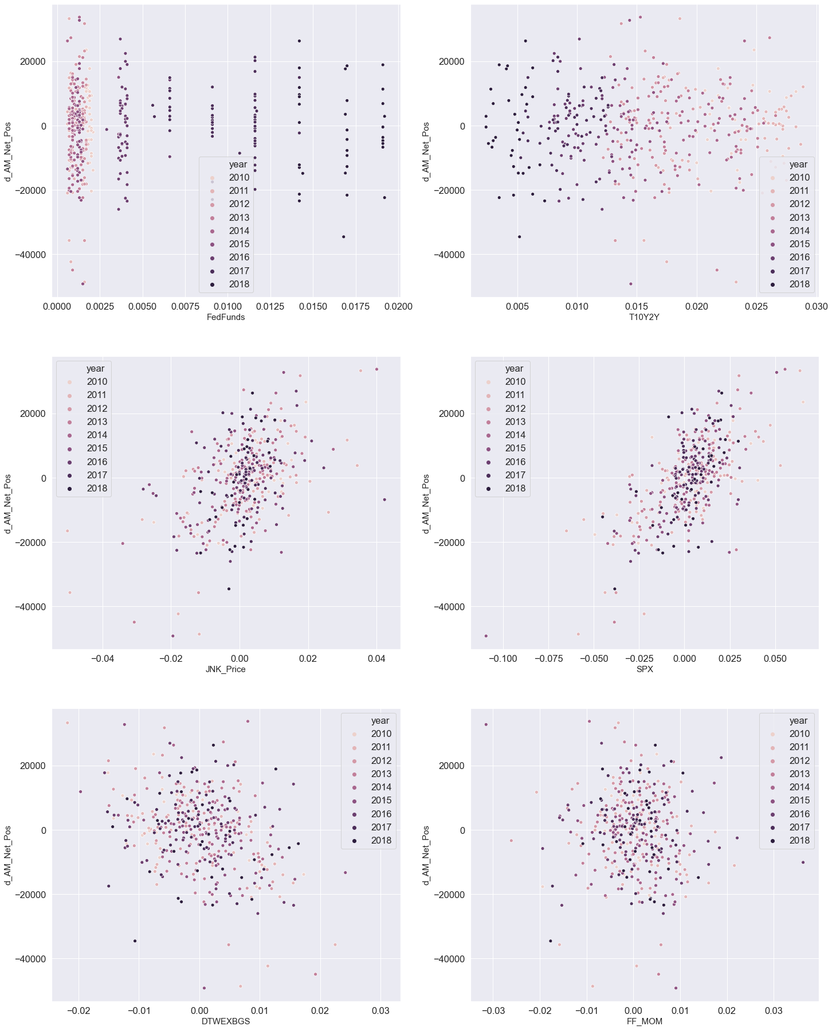

**Introduction**

Every Tuesday, Broker-Dealers, Asset Managers, Hedge Funds, and corporations report their financial futures positions to the Commodity Futures Trading Commission. Three days later, the CFTC releases the data in the “Traders of Financial Futures” section of the broader “Commitments of Traders” report to “help the public understand market dynamics[1].”

Equity Derivative Traders are also keen to understand market dynamics, and we hope to help them to do so ahead of the Friday release by predicting the result 4-days ahead of the release. Such a prediction might prove useful for desks to forecast both market sentiment and product demand among a strategically critical segment of the client base.

Moreover, our work extends the current literature on the CoT report in 3 important ways: the application of machine learning methods; focus on financial futures; and a shorter time horizon. Previous studies favor traditional methods of supervised learning, specifically linear regression. Moreover, most all focus on the relationship between position reports and commodity markets. Finally, the time horizon for prediction is typically monthly or annually. We are interested in predicting over a 4-day horizon.

**Economic Intuition and Structural Needs of Asset Managers**

We define our predictor groups, predictors, data sources, and economic intuition behind including these data elements. This latter task proved most challenging. If we assume asset managers take positions in futures to express market views, then it follows we should consider macro-economic indicators which are widely held to influence that sentiment. To that end, we include the usual suspects of interest rates, foreign currency rates, volumes, and market returns themselves. We eschewed less frequent or lagging indicators such as GDP, unemployment, and housing starts.

However, it is also possible asset managers seek futures exposure for reasons not related to views on the S&P. ETF providers, for example, use futures to equitize large cash inflows while trading into target positions. We include daily ETF flows for the two largest S&P ETF providers for that reason. It is also possible asset managers prefer future exposure to capture roll yield from the backwardation observed in S&P futures for most of the time since 2008. We will research futures premium / discounts to consider adding as a predictor in the model.

The table below summarizes the asset type, specific predictor, description, and our proposed intuition for including the variable.

**Data Summary[2]**



**Univariate Distributions**

We evaluate the distributions of our reponse and predictors to understand both the behavior and potential transformations necessary for our analysis. We combine variables of the same asset class for comporability.

*CoT Asset Manager Positions, HF Position*

Asset Managers hold more open interst long and short overall than hedge fund positions. Based on the count, it’s possible this because there are simply more asset managers and the average position for HF managers is more aggressive. HF managers are net short for most of the times series, while asset managers are net long.

It is worth considering whether these positions offset other expsoures, or if they are expressions of market views. There is also a data issue for counts in the first few weeks of the series*[3]*.

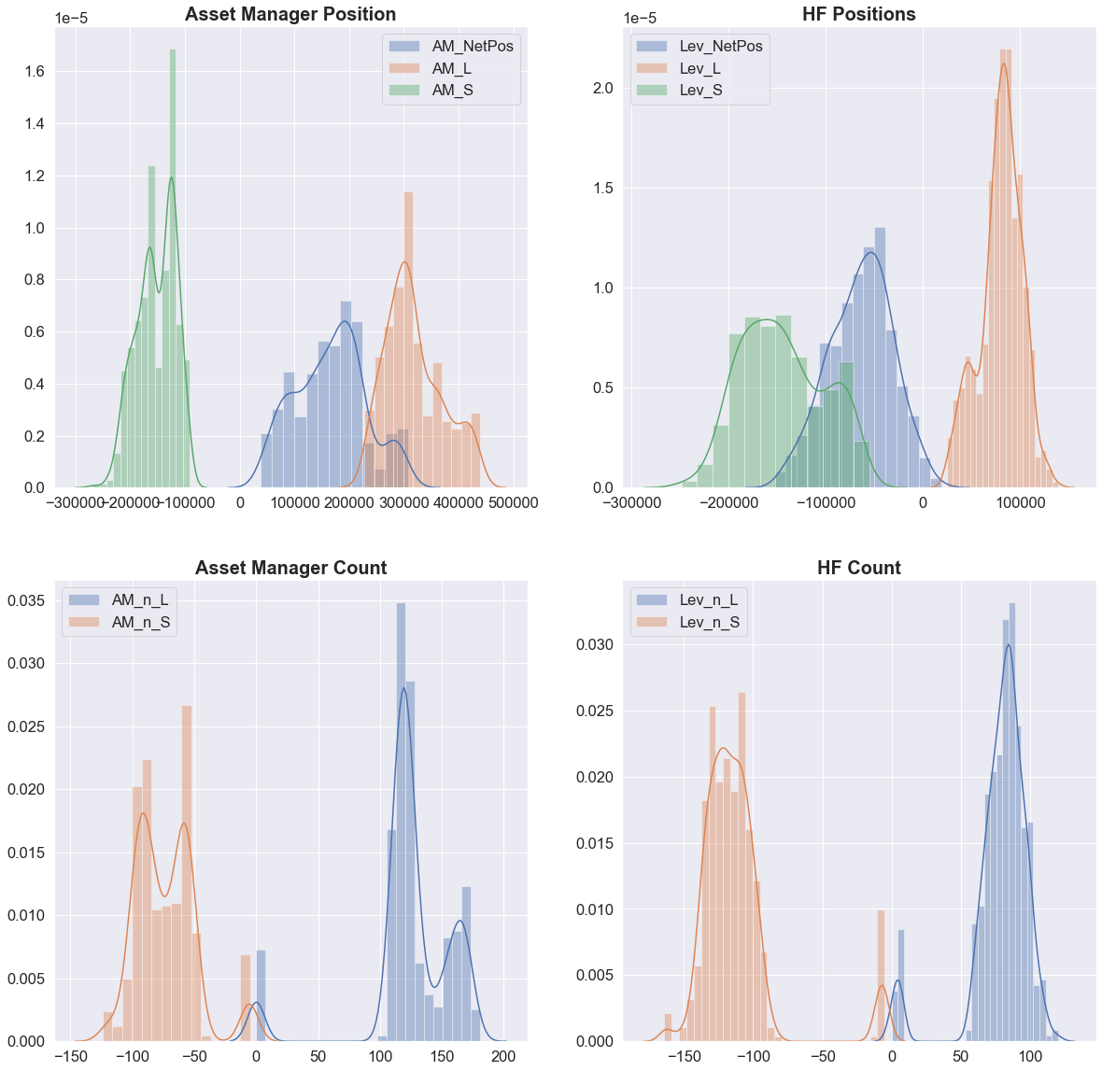

*Interest Rate, Inflation, FX Rates, and Credit Distributions:*

LIBOR and Fed Funds are close to zero and demonstrate little variability throughout the period. To the extent Asset Manager Net Positions have high serial correlaions, we would expect these variables to be “predictive” of the position. Of course, something that doesn’t change much at all is very good at predicting something else that doesn’t change much at all.

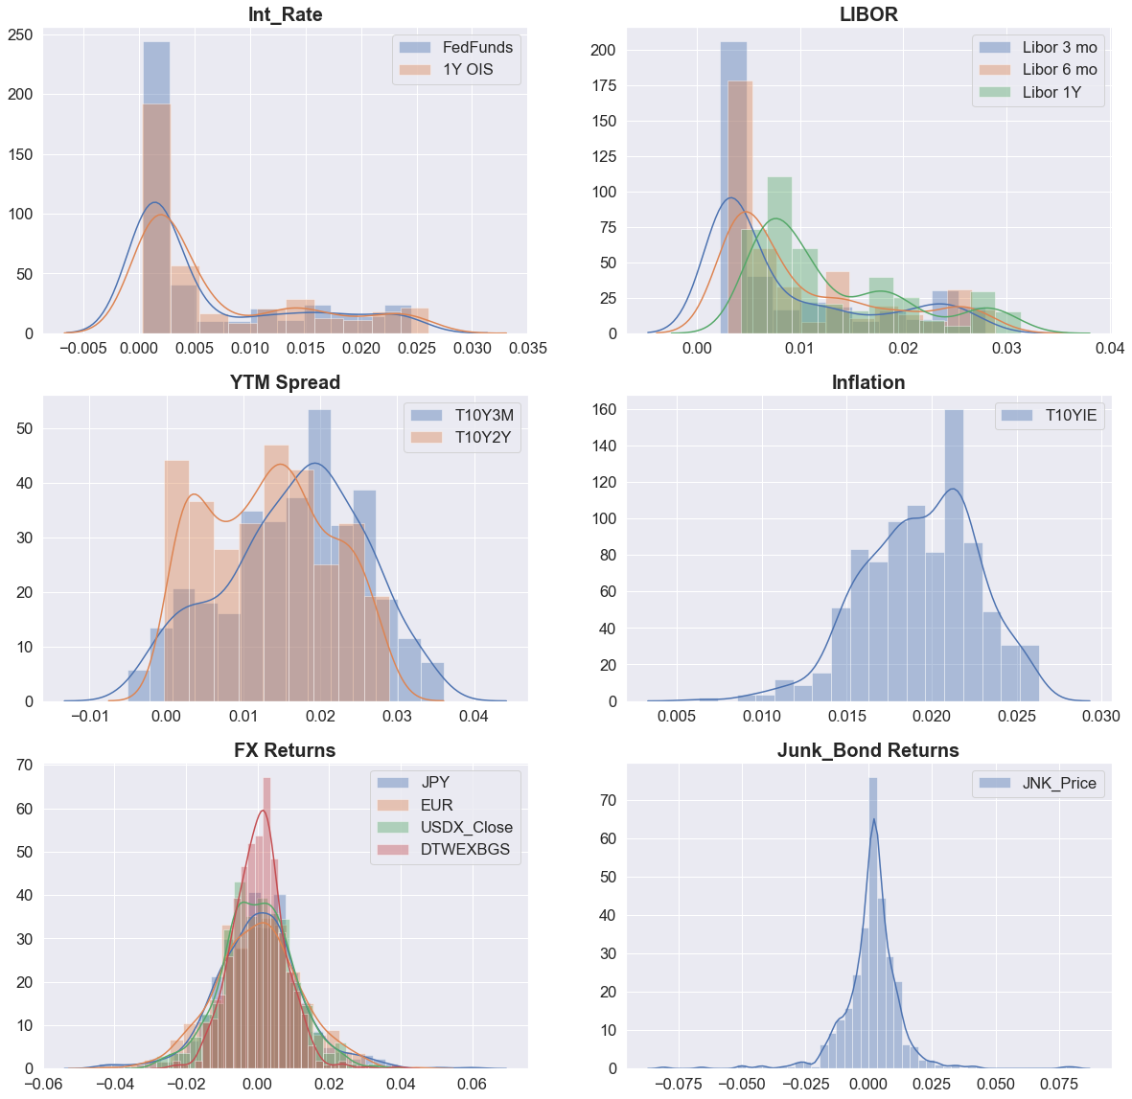

*Equity Returns, Commodity Returns, Volitility Levels, Fama French Factor Returns, ETF Flows:*

The equity returns appear quite similar and centered close to zero. Vol series all have substanital right skew, which could be an intersting regime signal. SPDR ETF Flows appear vastly different than iShares in distribution. We might consider exlcuding iShares given the number of “0” flow days.

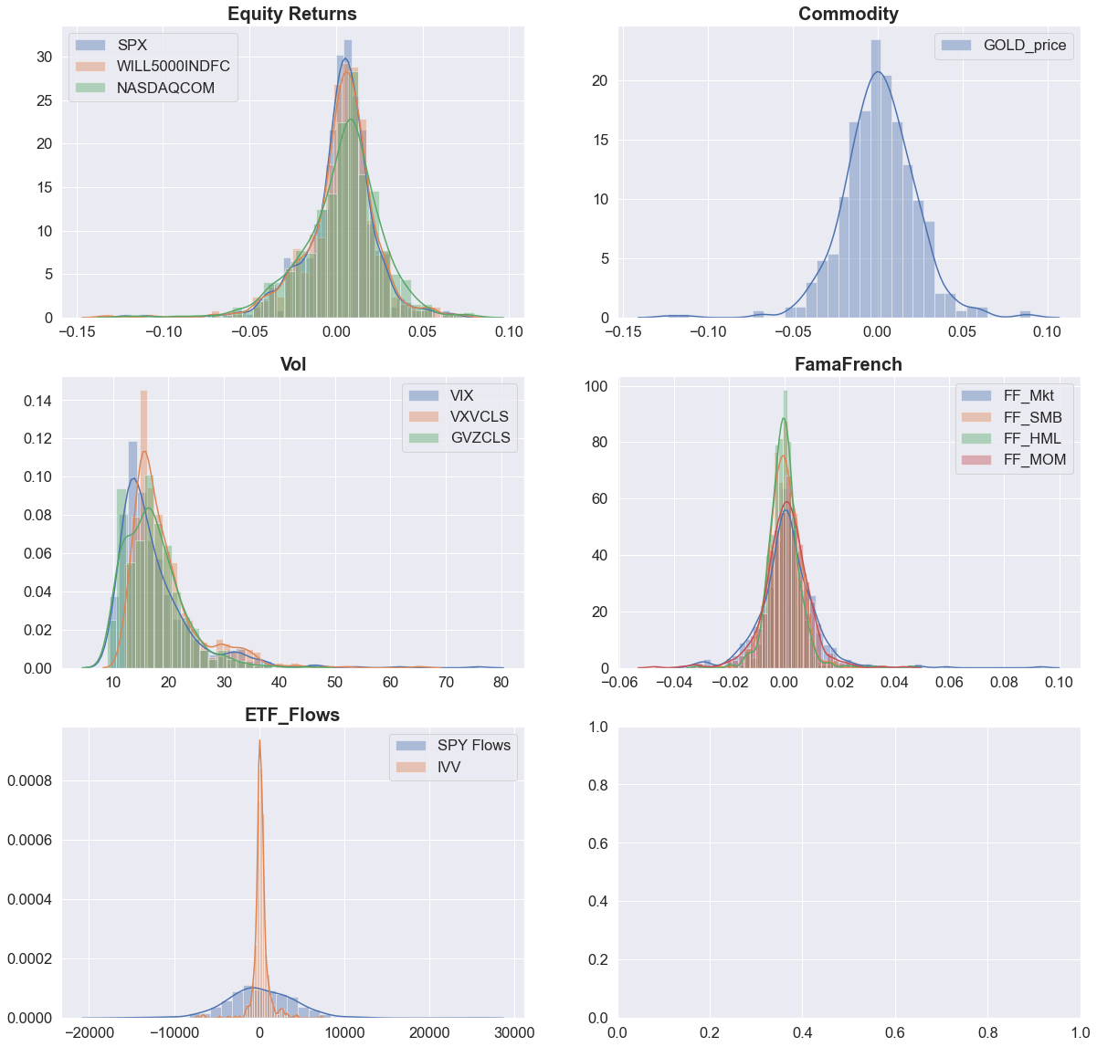

*1Y and Longer Duration: More Consitent Variability*

*Equity Returns: NASDAQ Strongest Positive Results*

**Correlations**

The table below depicts extreme positive correlations in red and extreme negative correlations in blue. Grouping by asset type, we observe high correlations among many of the predictors.

**Interest Rates** The short term interest rates are highly correlated as expected, but the duration slope measures are negatively correlated with the same variables. Increases in the far end of the yield curve also exhibit moderately negative correlation with inflation.

**Equity Returns** are highly correlated with each other, and negatively correlated with volatility measures. There is a slight positive correlation with JPY, a slight negative correlation with EUR, and a more negative correlation when trade balances are included

**CoT Positions** demonstrate the most interesting interactions, with varying levels of positive and negative correlation among the constituents.

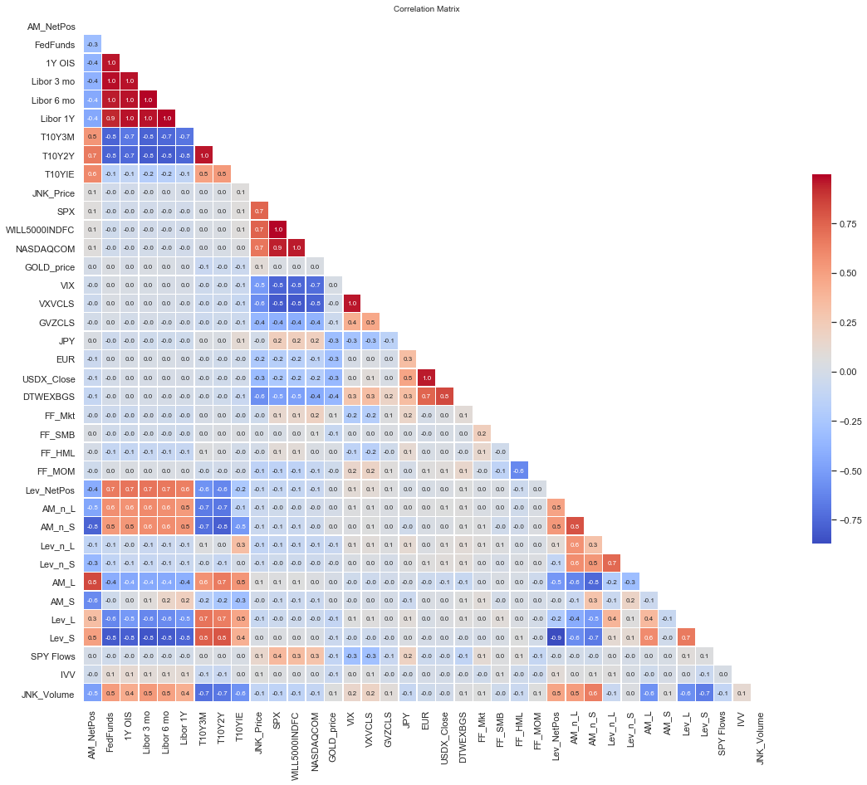

**Interest Rates**

**Equity**

**Vol**

**FX**

**FamaFrench**

**ETF Flows**

**CoT AM and HF**

**Response and Predictors Exploratory Analysis**

While we observe a positive .16 correlation between the Asset manager futures position and the leveraged manager futures position over the sample, a comparison of their time series shows substantial divergence within horizon. The extended periods of negative correlation suggest potential hidden economic states. Correlation within those states may stay relatively stable in terms of the sign of the correlation but the sign will change as the state shifts. We will pursue this line of questioning further by use of state models.

We see similar shifts in correlation between the response and other predictors:

Source: Bloomberg

**Response and Predictors Exploratory Analysis: Interest Rates**

The graphs below depict AM net position data compared with a range of interest rate measures. The years are color coded.

Overall, we observe higher readings in AM net positions when rates are low, particularly in 2011 and 2012. As rates increase, we observe a sharp drop around 25bps of the fed funds rate before the level increase again when fed funds reach 125 bps. Perhaps 25 bps marks the volatile transition point when the FOMC has already lowered rates in the midst of turmoil; at the final cut to near zero, market euphoria ensues. Similarly, as conditions improve, it’s possible markets react negatively to the first rate increase but further increases indicate strength.

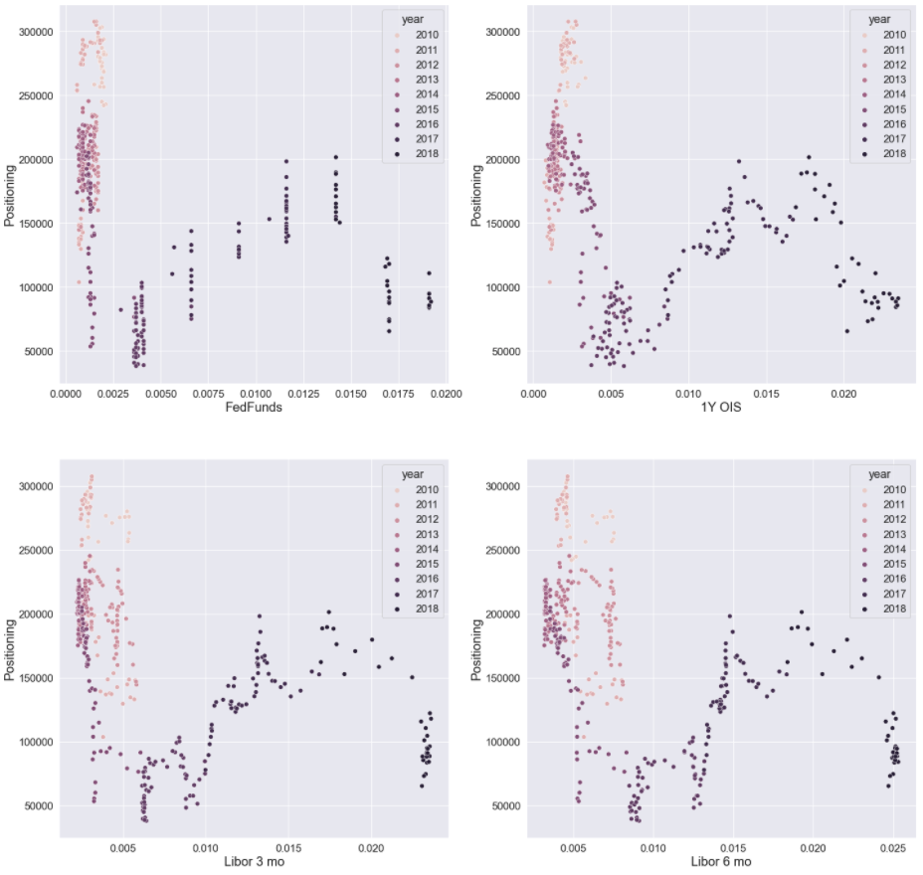

**Response and Predictors Exploratory Analysis: Commitments of Traders**

The previous week’s Long, Short, and Net positions are correlated with the current week’s Net position. The previous week’s net position, shown on the lower right, demonstrates a high level of serial correlation. The lagged hedge fund data appear to have somewhat of a linear relationship, though substantially less dispersion.

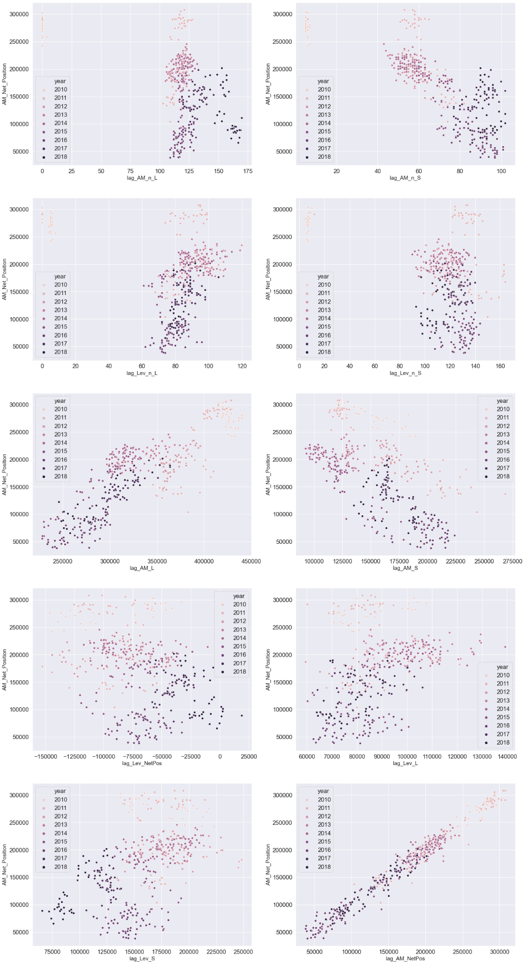

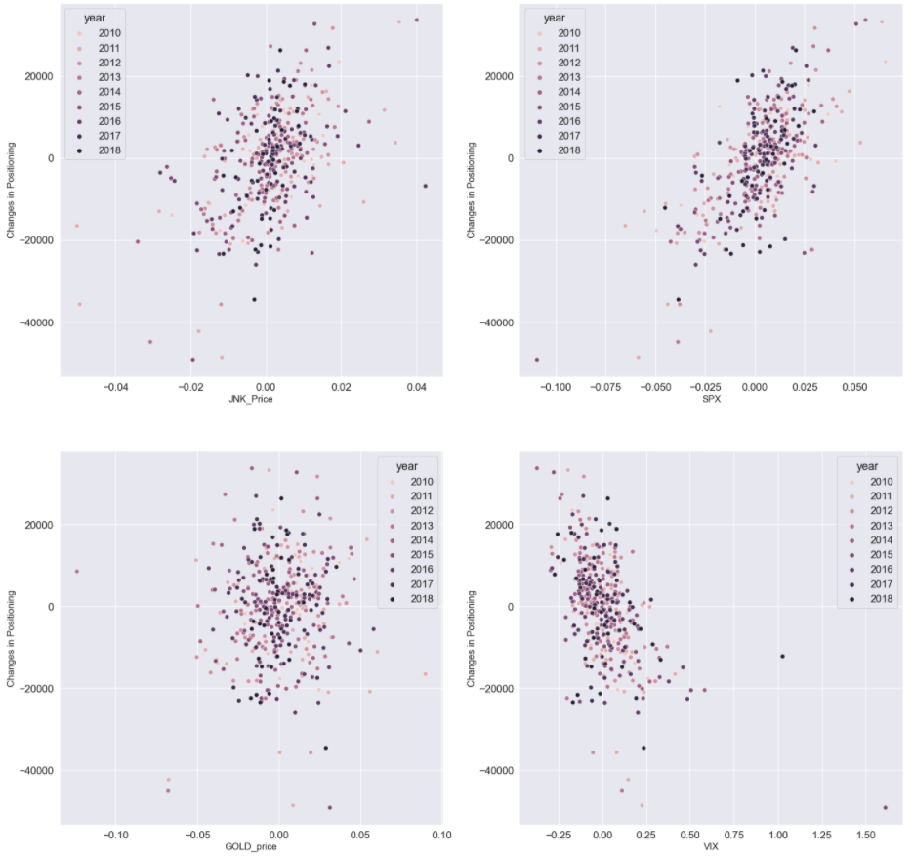**Equity Returns**

We observe positive correlation between changes in net asset positioning and returns on the S&P500 for the previous week. It’s likely momentum influences the net exposure of asset managers.

We will compare changes in positions to changes in other variable levels as well as we continue feature generation.

**Baseline: Ridge**

*Train / Test MAE: 6033 / 14,935*

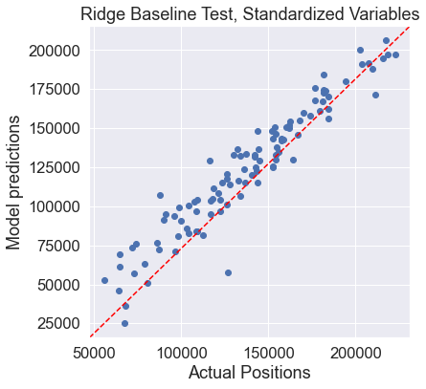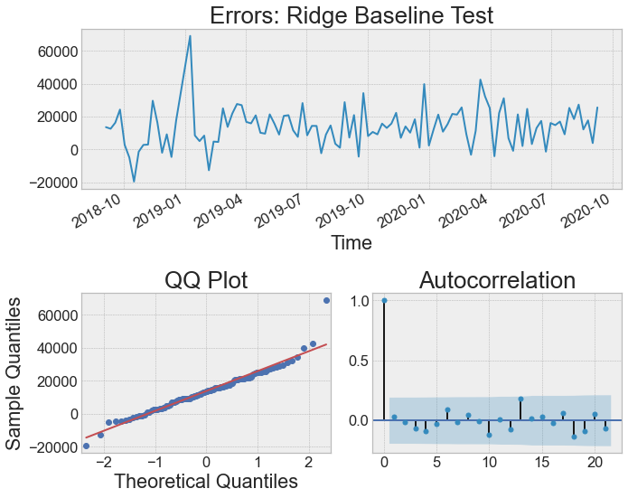

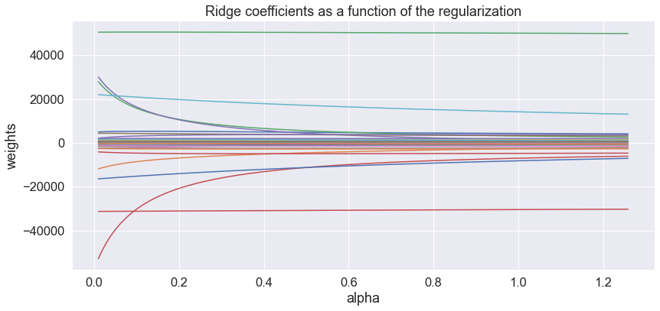

**Baseline: Lasso**

*Train / Test MAE: 6248 / 17,694*

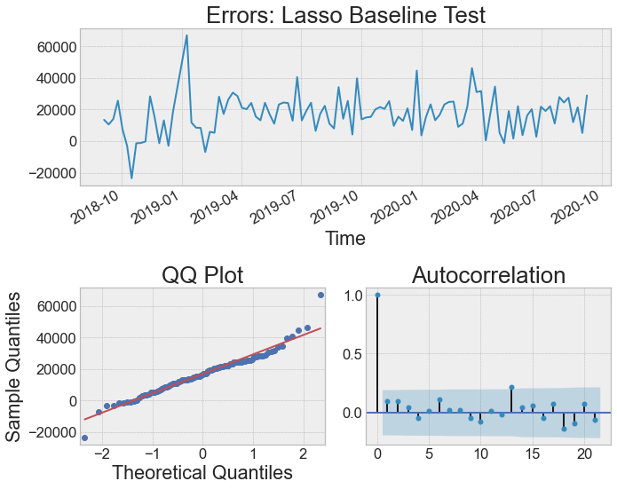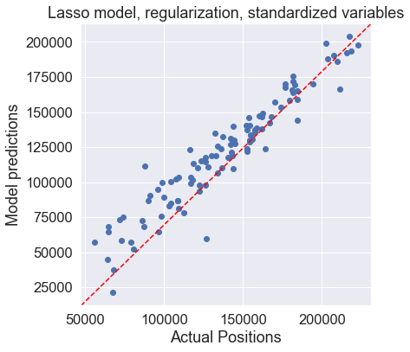

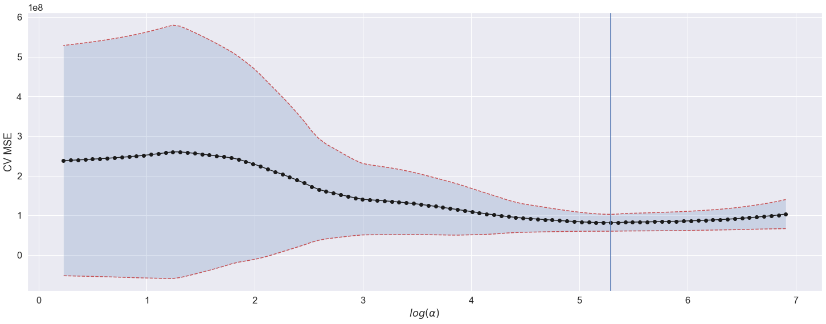

**Baseline: Random Forest**

*Train / Test MAE: 3746 / 27,111*

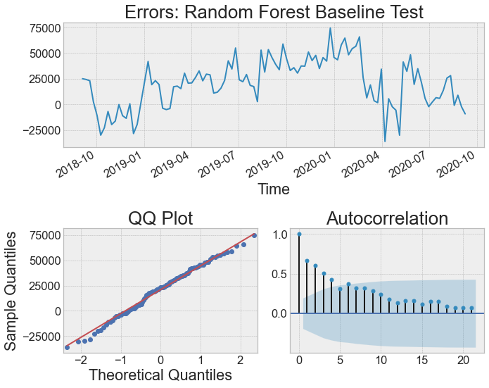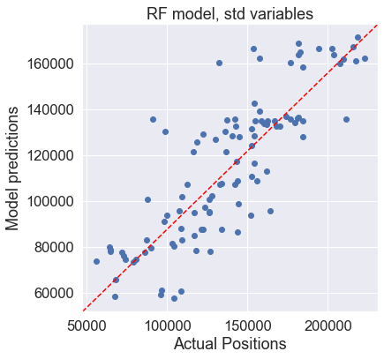

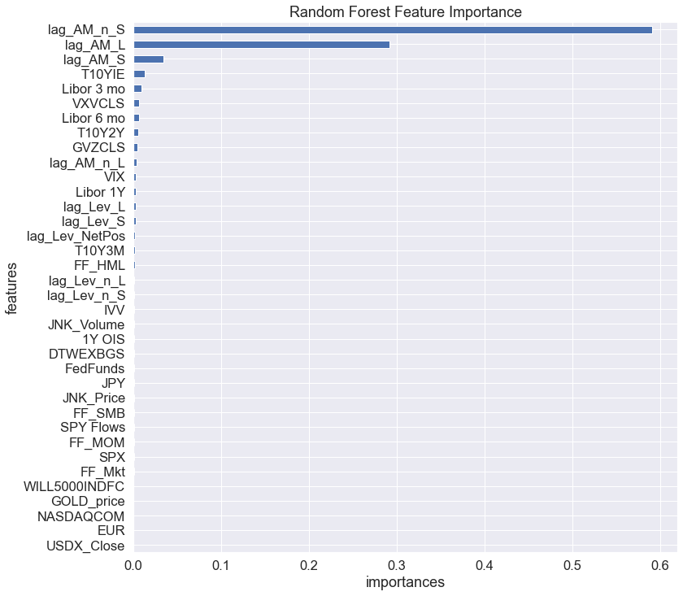

**Comparison**

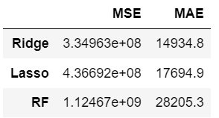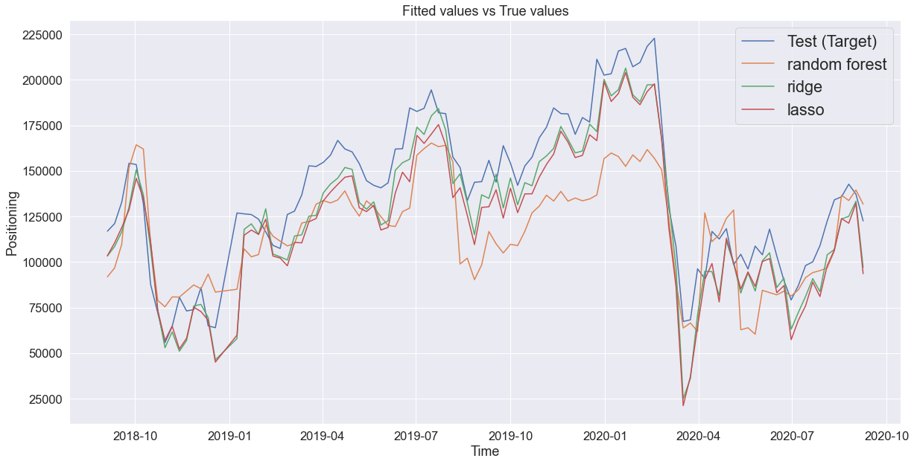

**Change in Net Positions: Ridge**

*Train / Test MAE: 6035 / 14,837*

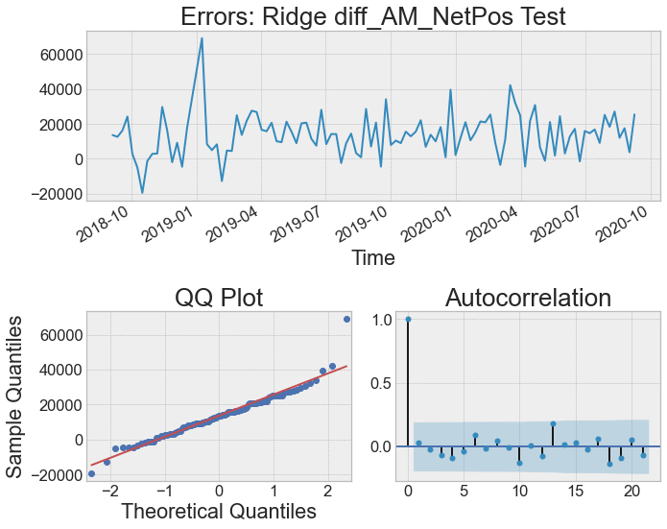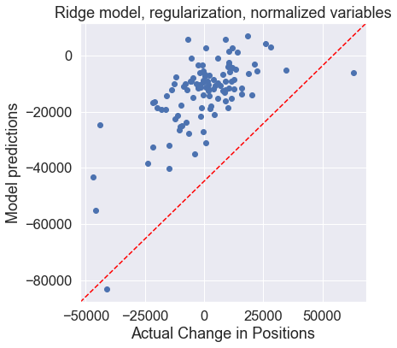

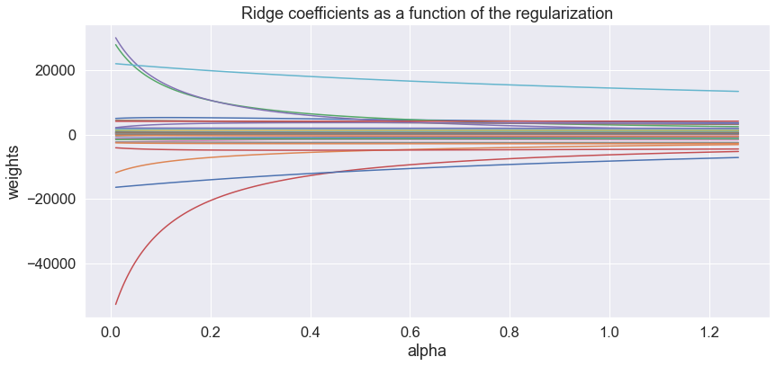

**Change in Net Positions: Lasso**

*Train / Test MAE: 6394 / 11,349*

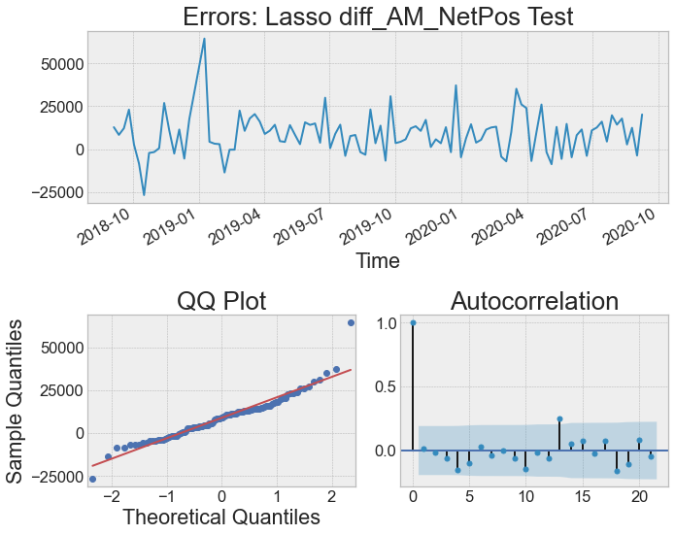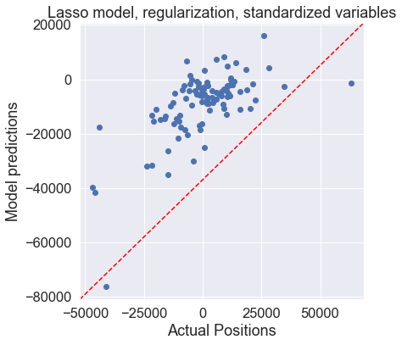

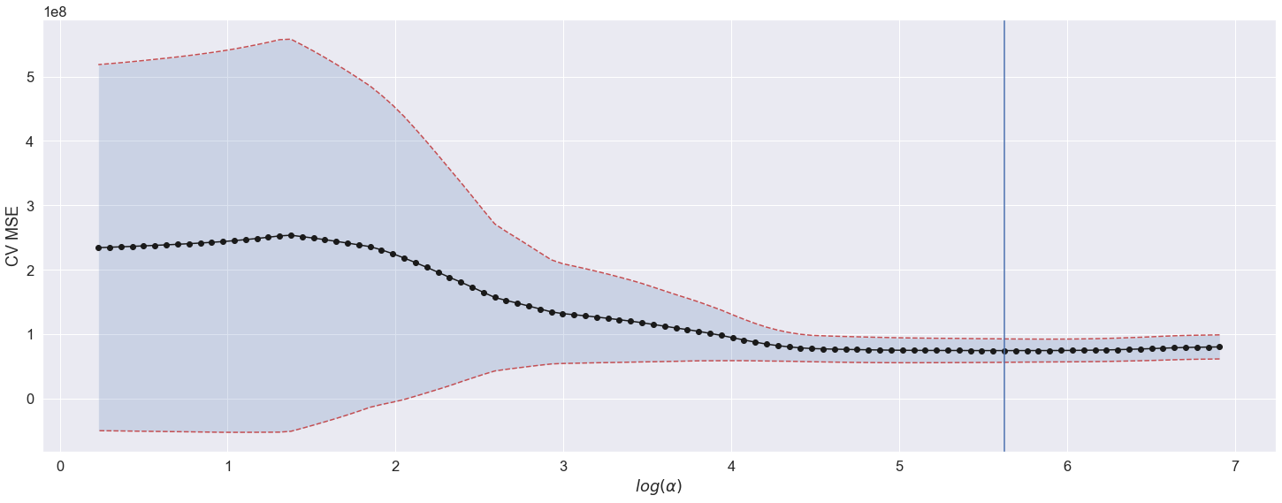

**Change in Net Positions: Random Forest**

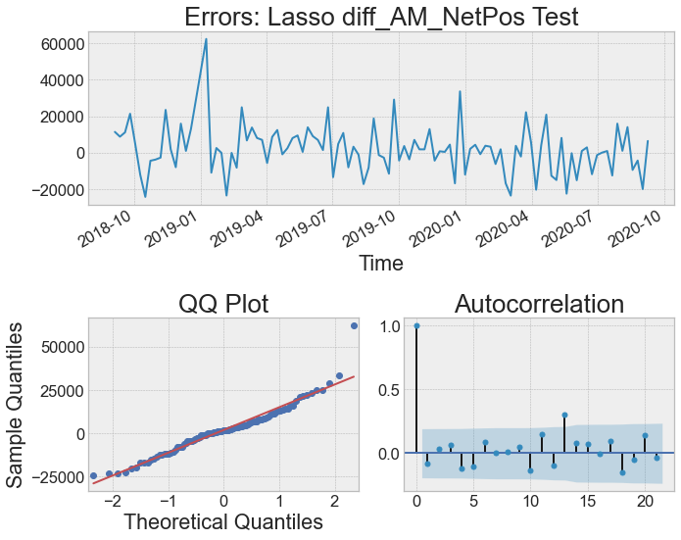

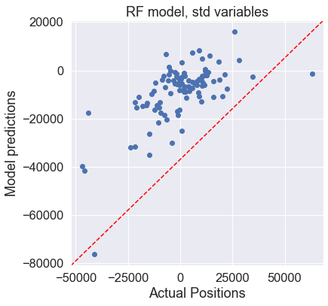

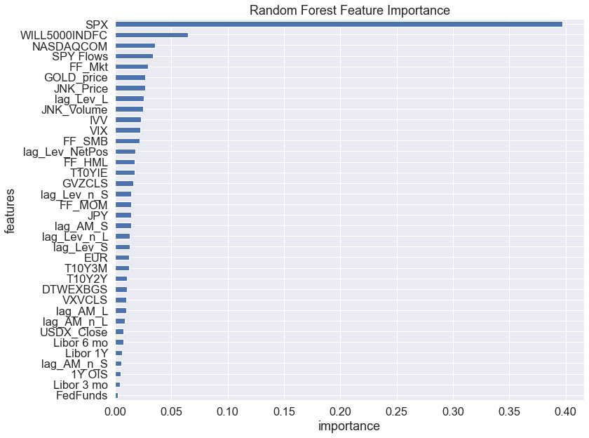

**Comparison**

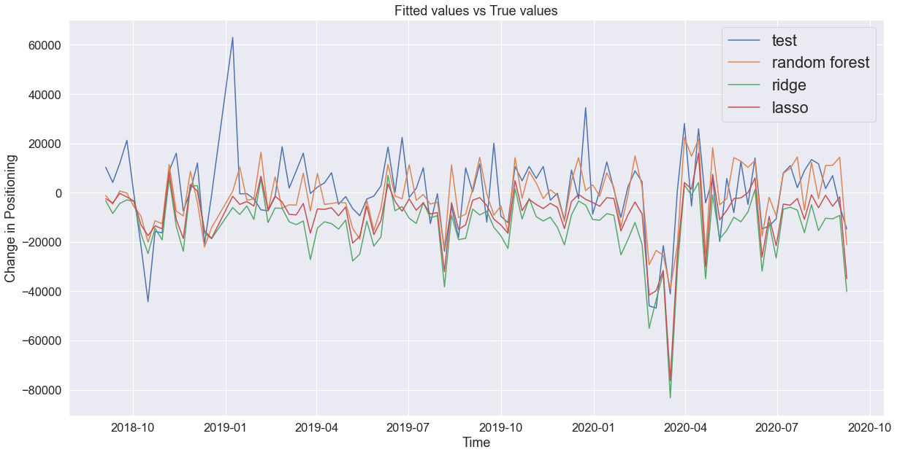

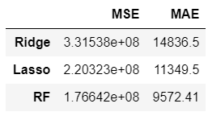

**Variable Selection**

|  |  |  |
| --- | --- | --- |
|  | **Baseline** | **Change in Net Position** |
| **Lasso** | T10Y3M  T10YIE  SPX  GOLD_price  VIX  GVZCL  JPY  EUR  FF_Mkt  FF_SMB  FF_MOM  SPY Flows  JNK_Volume  lag_Lev_n_S  lag_AM_L  lag_AM_S  lag_Lev_L | T10Y3M    SPX  GOLD_price  VIX  GVZCLS  JPY  EUR  FF_Mkt  FF_SMB  SPY Flows  JNK_Volume  lag_Lev_n_S  lag_AM_L  lag_AM_S  lag_Lev_L |
| **Random Forest** | lag_AM_n_S  lag_AM_L  lag_AM_S  T10YIE  LIBOR3M  lag_AM_n_L | SPX  WILL5000INDFC  SPY Flows  NASDAQCOM  FF_SMB  FF_Mkt  GOLD_price  VIX  lag_Lev_L  FF_HML |

**Proposed Next Steps**

We found some interesting patterns in the data:

* AM Net Positions Demonstrate High Serial Correlation
* Commitments of Traders Data frequently appeared in Random Forest and Lasso Variable Selection
* SPX weekly returns appear to be related to *the change* in AM Net Positions
* correlations vary significantly across time for many responses and predictors

To build on these observations, we propose:

* Vector Auto Regressive Time Series with Variable Selection: Our hope is to identify time series patterns which can help us to better predict the next period.
* Hidden Markov Model: Given the wide variation in correlations, we’d like to apply a hidden Markov model which would classify the time series into different states, providing different predictions based on the states.
* Commitments of Traders Feature Generation: With many of these data points appearing in the variable selection, we’ll research additional features based on both published articles and our own research.
* Additional Feature Generation: Based on our Exploratory Data Analysis, we will consider excluding co-linear predictors from the opportunity set while also considering other combinations. The correlation data will provide a starting point.
* “Risk On / “Risk Off” Regime Model: Is it possible the level of Asset Manager open net interest in futures is driven by broader macro regimes of ‘risk on’ and ‘risk off’?
* Daily prediction: Consider how the evolution of time series might provide more information to predict the weekly futures position.

**Limitations and Areas for Future Study**

**1. Inclusion of S&P eMini Futures**

**2. Consider removing the trend with time series, and model the impact of the other variables**

**3. Understanding the role Futures play for Asset Managers**

**4. Dividend Policy and Futures Curves**

**Appendix**

**A. Data Validation and Extension**

We added 52 potential predictors and 20 months of data to the set. June 2010 marks the first date we were able to locate reliable CoT data. We also included additional predictors for interest rates, foreign exchange, credit, equity, and commodity markets. Following our initial literature review, we also augmented the CoT Traders of Financial Futures Asset Manager and Hedge Fund Manager net positions with long and short position data, as well as long and short concentration data for the same time periods.

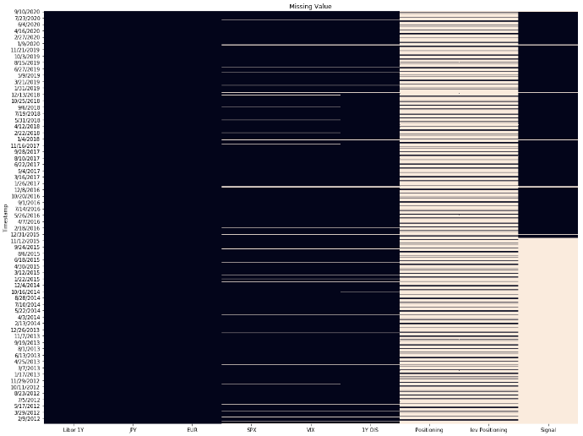Initial Data Set Extended Data Set

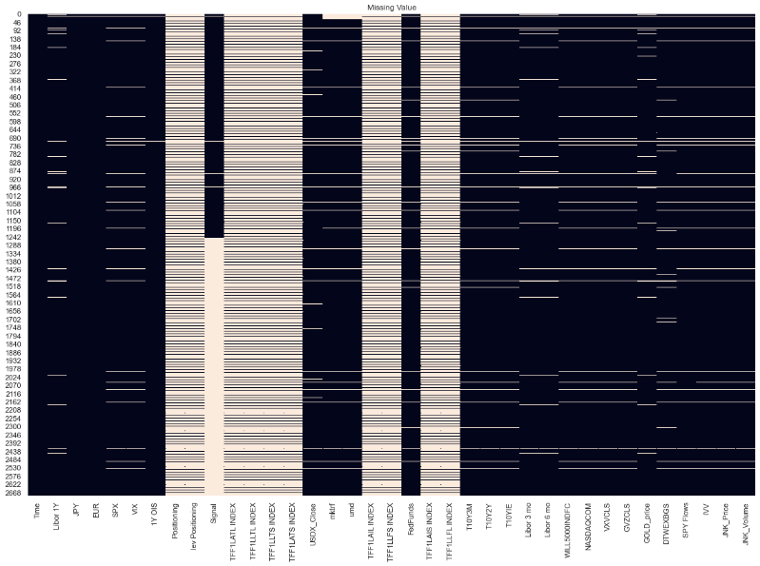

*Source: Client, Bloomberg, FRED, WRDS*

We then tested the augmented data for accuracy, completeness, and timeliness.

We identified accuracy exceptions in our LIBOR, Fama French, and FX Data sets. LIBOR appeared to be a reporting difference between FRED and Bloomberg, so we opted for Bloomberg. Fama French data were staled for a 3 month period, which we resolved with the September 30 update. The FX data we gathered were not aligned; some were Foreign |USD while others were in USD | Foreign terms. We normalized all to Foreign|USD, so a positive return indicates USD strengthening, while a negative return indicates a weakening with respect to the foreign currency.

For equity indices, we preferred price indices adjusted for dividends over total return indices. While we use returns as a predictor, we thought the price movements would influence asset manager positioning in futures, which explicitly do not pay dividends.

The completeness issues were confined to holiday reporting issues, where interest rate and currency rates reported values while US-based equity indicators and the CoT did not. For consistency, we eliminated the holidays from the data set.

For timeliness, we found the Fama French factor returns were only updated quarterly. However, these would be possible to replicate daily should they move to production. The CoT data are released weekly with a 4 day lag; to account for this, we lag the predictor-variables in the data set across all analyses.

To aggregate our data from daily to weekly, we evaluated transformations for each group of predictors. We left interest rates, duration spreads, and credit spreads unchanged based on the assumption that the level of the interest rate itself is an important variable. We calculated simple returns[4] for Foreign Currency, Equity, Commodity, and Fixed Income indices, and aggregated ETF flow data by summing the values for the previous week. For volume data, we took an average for the previous week.

For the Commitment of Traders Data, we lagged Asset Manager and Hedge Fund Long Positions, Asset Manager and Hedge Fund Long Short Positions, Hedge Fund Net positions, as well as position counts for these variables.

It is worth noting we define “week” to encompass the period from Wednesday morning to Tuesday night to align with our desired response prediction. We have 529 weekly periods compared with 2583 daily periods. We retain the daily set for potential use in unsupervised learning and feature generation.

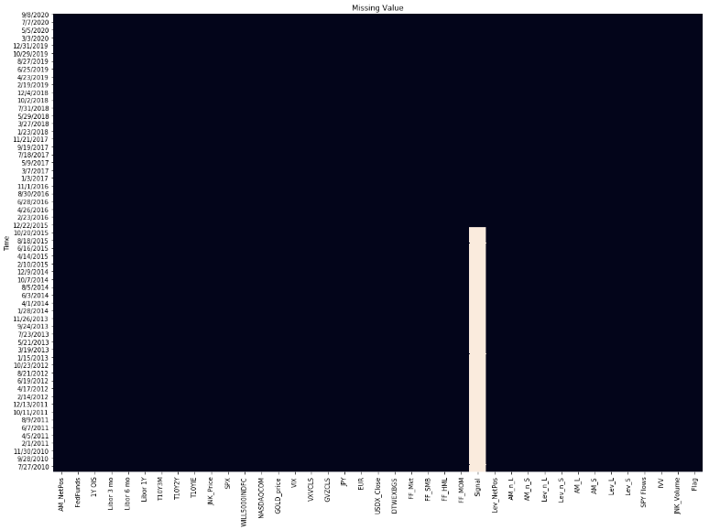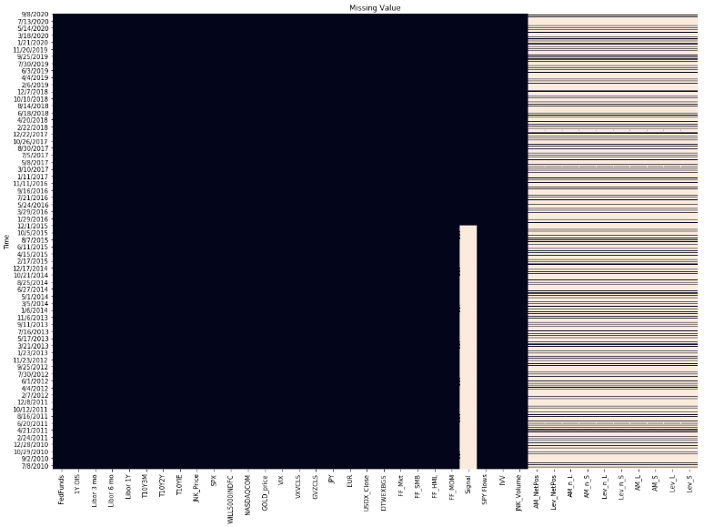Below please find a visualization of the scrubbed daily data and weekly data sets, with most recent on top:

**B. Data Dictionary**

We provide the data dictionary for completeness and replicability.

*Category:* Classification of the data element by asset class, origin, or subtype within a broader group

*Short Name:* Variable names used in our code

*FRED / Bloomberg Code:* Tickers for each element from the source of that element



*Should We Include Futures & Options Data Set? No*

The CFTC also provides a Traders in Financial Futures combined with reported Options positions. We explored this data set, and found the information did not differ significantly from the TFF data set. In particular, comparing the equivalent response variable from the combined data set to our own, we find minimal differences:

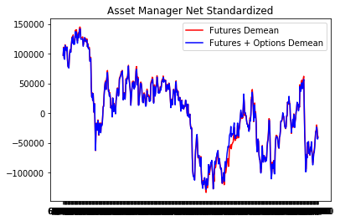

*List of Questions to Research*



*Literature Review Notes*

(Briese, 2008)

COT/Commodities – Commercial buying/selling extreme (100%/0% COT Index) (Briese, 2008)

COT/Open interest in asset managers vs hedge funds p 29

COT/Price – asset price level as a driver of changes

COT Momentum (rate of change – say, over 6 weeks Briese, 2008)

* Test ranges, test levels, identify comovement with stocks

**Potential Areas for Exploration**

Breise 2008

* CBOT Liquidity data bank – available intra-day, based on volume. Does not separate traders, but between exchange members and others. Only volume and price.
* Only hedge funds / speculator positions provide information, “non-commercial spreads” muddies the waters. P41
* Net / Gross positions vary by trader, market, time period p63 (Breise, 2008)
* Options Data
* Leveraged Information
* Non-traditional (sentiment, textual data)
* Combination of Chicago vs NY Markets
* Are people’s actions on Wednesday, Thurs influenced by their positions on Tuesday? (Prof G’Sell)
* Consider modeling the E-Mini and SP500 together

**Key Concepts**

Open interest – total number of open contracts at the close of trading. Total number of longs, or total number of shorts – not the combination, since futures are zero sum.

Arbitrageurs are listed as speculators

Negative correlations w/ 2yr treasury, LIBOR,

**Bibliography**

Aragon, George O., Mehra Rajnish, Wahal. 2020. "[Do Properly Anticipated Prices Fluctuate Randomly?,](http://doi.org/10.3905/jpm.2020.1.158)" The Journal of Portfolio Management, vol 46(7), pages 144-159.

Bhardwaj, G., Gorton, G. B., & Rouwenhorst, K. G. (2016). Investor interest and the returns to commodity investing.*Journal of Portfolio Management, 42*(3), 44-55. doi:http://dx.doi.org.proxy.library.cmu.edu/10.3905/jpm.2016.42.3.044

Briese, Stephen, and Joseph Jaffe. *The Commitments of Traders Bible : How to Profit from Insider Market Intelligence*, John Wiley & Sons, Incorporated, 2008. ProQuest Ebook Central, https://www-proquest-com.proxy.library.cmu.edu/legacydocview/EBC/335757?accountid=9902.

Campbell, J. and Thompson, S. Predicting Excess Returns Out Of Sample: Can Anything Beat The Historical Average? Review of Financial Studies, 21:1509–1531, 2008.

Chatrath, A., Liang, Y., & Song, F. (1997). COMMITMENT OF TRADERS, BASIS BEHAVIOR, AND THE ISSUE OF RISK PREMIA IN FUTURES MARKETS: INTRODUCTION.*The Journal of Futures Markets (1986-1998), 17*(6), 707. Retrieved from https://www-proquest-com.proxy.library.cmu.edu/docview/225486270?accountid=9902

Fagan, S. (2012). *Large traders in financial markets*(Order No. NS23210). Available from ProQuest Dissertations & Theses Global. (1515762417). Retrieved from <https://www-proquest-com.proxy.library.cmu.edu/docview/1515762417?accountid=9902>

Kearns, Manners (2004) *The Profitability of Speculators in Currency Futures Markets (as cited in Briese 2008, p 94)*

Maul, D., Fischer, M., & Schiereck, D. (2015). Spekulation am terminmarkt und die preisentwicklung von agrarrohstoffen am kassamarkt: Eine zeitreihenanalyse der CFTC berichte für weizen, mais und sojabohnen / speculation in futures markets and the impact on agricultural commodity prices: A time series analysis of the CFTC reports for wheat, corn and soybeans.*Jahrbücher Für Nationalökonomie Und Statistik, 235*(6), 608-629. doi:http://dx.doi.org.proxy.library.cmu.edu/10.1515/jbnst-2015-0606

Often, E. M., & Wisen, C. H. (2013). Disaggregated commitment of traders data and prospective price effects.*Journal of Applied Business Research, 29*(5), 1381-n/a. Retrieved from https://www-proquest-com.proxy.library.cmu.edu/docview/1473895453?accountid=9902

Raisler, K. M., Gilberg, D. J., & Sullivan, D. C. (2006). CFTC REVIEW OF COMMITMENTS OF TRADERS REPORTING PROGRAM.*Derivatives Financial Products Reports, 7*(12), 1-4. Retrieved from https://www-proquest-com.proxy.library.cmu.edu/docview/200617025?accountid=9902

Sanders, D. R., Keith, B., & Manfredo, M. (2004). Hedgers, funds, and small speculators in the energy futures markets: An analysis of the CFTC's commitments of traders reports.*Energy Economics, 26*(3), 425-445. doi:http://dx.doi.org.proxy.library.cmu.edu/10.1016/S0140-9883(04)00020-9

Sanders, D. R., & Irwin, S. H. (2011). The impact of index funds in commodity futures markets: A systems approach.*The Journal of Alternative Investments, 14*(1), 40-49,8. Retrieved from https://www-proquest-com.proxy.library.cmu.edu/docview/878740679?accountid=9902

Yung, K., & Liu, Y. (2009). Implications of futures trading volume: Hedgers versus speculators.*Journal of Asset Management, 10*(5), 318-337. doi:http://dx.doi.org.proxy.library.cmu.edu/10.1057/jam.2009.31

MARKET TALK: CFTC computer problem delays commitments of traders - CFTC. (2010, Sep 24). *Dow Jones Institutional News* Retrieved from https://www-proquest-com.proxy.library.cmu.edu/docview/2167866459?accountid=9902

1. <https://www.cftc.gov/MarketReports/CommitmentsofTraders/index.htm>, accessed 10/31/2020
2. Please see appendix for additional information
3. The approach to count significant asset managers changed on January 4, 2011.
4. Please see Campbell, Thompson (2008) p 1516, who note “all forecasts tend to underpredict return when log returns are used.” The difference between log and simple returns is most pronounced during periods of high volatility, when log returns at the extreme are lower in magnitude than the corresponding simple return.